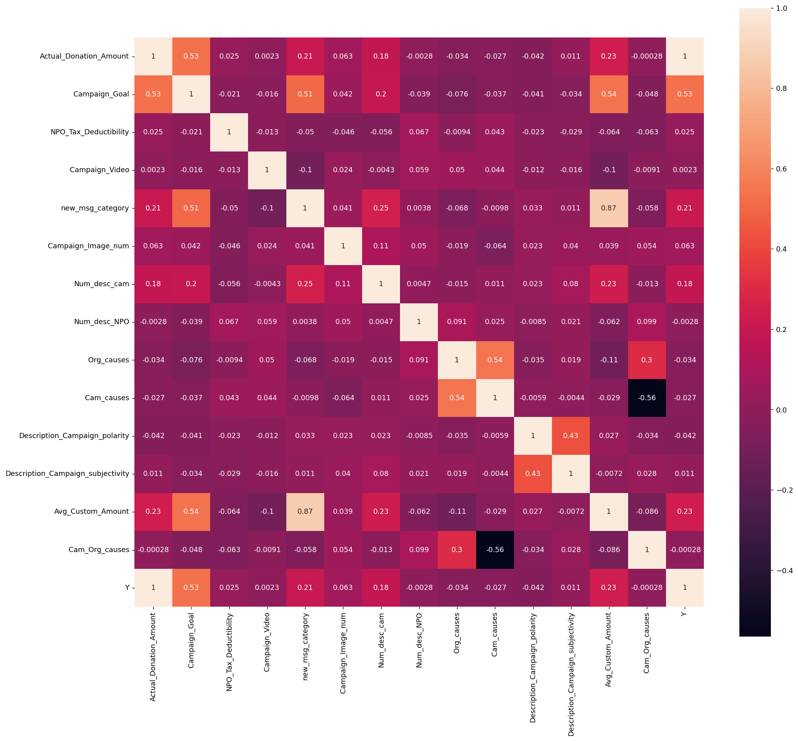

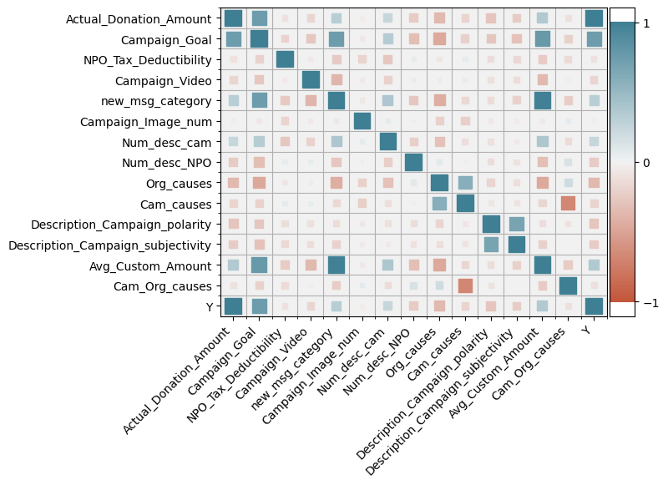

New Model

Please pay attention to it. Almost all the numbers are changed.

Table1 correlation Matrix and descriptive statistics

|  |  |  |  |  |  |  |  |  |  |  |  |  |  |  |  |  |  |  |
| --- | --- | --- | --- | --- | --- | --- | --- | --- | --- | --- | --- | --- | --- | --- | --- | --- | --- | --- |
|  |  | Mean | Std.Dev | Min | Max | [1] | [2] | [3] | [4] | [5] | [6] | [7] | [8] | [9] | [10] | [11] | [12] | [13] |
| [1] | DV:Donation Amount | 9813 | 62978 | 0 | 3431670 | 1 |  |  |  |  |  |  |  |  |  |  |  |  |
| [2] | Campaign Goal | 44797 | 154417 | 100 | 5000000 | 0.53 | 1 |  |  |  |  |  |  |  |  |  |  |  |
| [3] | Tax Deductibility | 0.939 | 0.240 | 0 | 1 | 0.025 | -0.021 | 1 |  |  |  |  |  |  |  |  |  |  |
| [4] | Video use | 0.404 | 0.491 | 0 | 1 | 0.002 | -0.016 | -0.013 | 1 |  |  |  |  |  |  |  |  |  |
| [5] | Impact message | 1.183 | 1.205 | 0 | 3 | 0.21 | 0.51 | -0.05 | -0.1 | 1 |  |  |  |  |  |  |  |  |
| [6] | Number of images | 2.870 | 1.589 | 0 | 5 | 0.063 | 0.042 | -0.046 | -0.024 | 0.041 | 1 |  |  |  |  |  |  |  |
| [7] | Words of campaign | 138 | 67.5 | 1 | 309 | 0.18 | 0.2 | -0.056 | -0.0043 | 0.25 | 0.11 | 1 |  |  |  |  |  |  |
| [8] | Words of NPO | 101 | 56.1 | 1 | 179 | -0.003 | -0.039 | 0.067 | 0.059 | 0.0038 | 0.05 | 0.005 | 1 |  |  |  |  |  |
| [9] | Organization Cause | 3.033 | 1.536 | 0 | 5 | -0.034 | -0.076 | -0.009 | 0.05 | -0.068 | -0.019 | -0.015 | 0.09 | 1 |  |  |  |  |
| [10] | Campaign Cause | 3.456 | 0.982 | 0 | 4 | -0.027 | -0.037 | 0.043 | 0.044 | -0.01 | -0.064 | 0.011 | 0.025 | 0.54 | 1 |  |  |  |
| [11] | Description_Campaign_polarity | 0.165 | 0.155 | -0.8 | 1 | -0.042 | -0.041 | -0.023 | -0.012 | 0.033 | 0.023 | 0.023 | -0.008 | -0.035 | 0.006 | 1 |  |  |
| [12] | Description_Campaign_subjectivity | 0.422 | 0.143 | 0 | 1 | 0.011 | -0.034 | -0.029 | -0.016 | 0.11 | 0.04 | 0.08 | 0.021 | 0.019 | -0.004 | 0.43 | 1 |  |
| [13] | Avg_Custom_Amount | 243.40 | 7312 | 0.0 | 900000 | 0.23 | 0.54 | -0.064 | -0.1 | 0.87 | 0.039 | 0.23 | -0.062 | -0.11 | -0.029 | 0.027 | -0.0072 | 1 |
| [14] | Cam_Org_causes | 0.2038 | 0.8683 | -3 | 5 | 0 | -0.048 | -0.063 | -0.009 | -0.058 | 0.054 | -0.013 | 0.099 | 0.3 | -0.56 | -0.0340 | 0.028 | -0.086 |

The new regression result.

Before BOX-COX translation.

After BOX-COX translation.

